INTRODUCTION TO SHAMANISM

CECILE CARSON, MD

Lafayette, Louisiana February 16 - 17, 2019

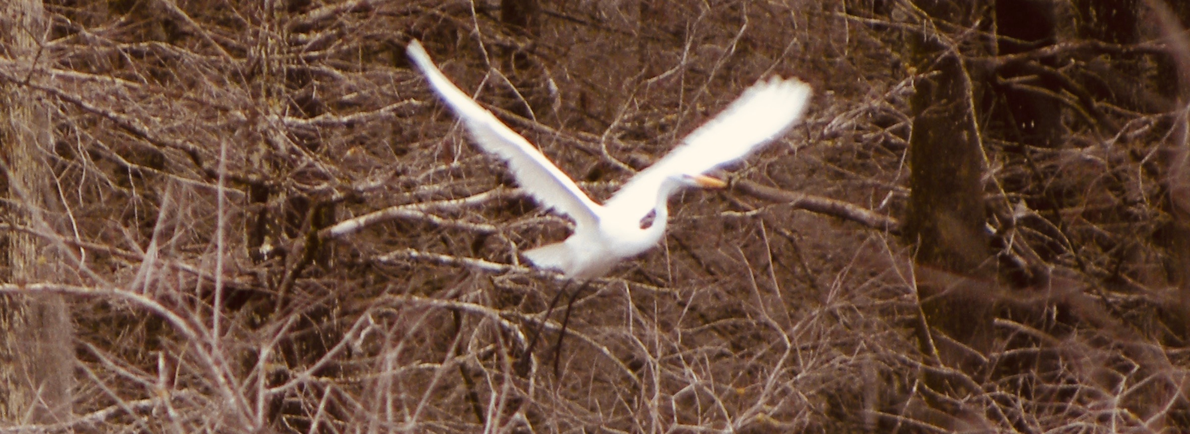

Shamanism is the most ancient path of direct revelation; its practice is at least 20,000 years old. In this workshop, you will be introduced to the shamanic journey, a form of shifting consciousness that allows you to move from ordinary reality to “non-ordinary reality” -- a dimension in which everything is alive and has spirit. It is one of the most profound visionary methods used by humans to explore the hidden universe known mostly through myth and dreams. Aided by drums, rattles, and ceremony, participants will be initiated into journeying to help restore spiritual power and health.

In addition, this two-day workshop on core shamanism will introduce several forms of shamanic divination and shamanic healing, as well as practical applications of this ancient form to contemporary life to benefit oneself, others, and the planet.

The workshop will run from 9-6 on Saturday and 1-6 Sunday. Please bring a drum or rattle if you have one. Wear comfortable clothing, and bring an eye cover, a blanket, and a pen and notebook to record your journeys.

Cecile Carson is an experienced teacher and shamanic worker for the past 27 years who has integrated shamanic principles into her Western medical practice. She has had extensive training through the Foundation for Shamanic Studies and has studied in Romani (gypsy) and Celtic traditions as well. She is a Founding Board member of the Society for Shamanic Practice and editor of Spirited Medicine: Shamanism in Contemporary Healthcare.

TO REGISTER, CONTACT: Cecile Carson, Integrated Health Institute, 413 Begnaud Drive, Lafayette, LA, 70501. cecile@cecilecarson.com 585-271-5650

FEE: $190 for the training. (A $70 non-refundable deposit is required to hold your space in the group.) Call or email for registration form.

REGISTRATION

INTRODUCTION TO SHAMANISM

CECILE CARSON, MD

Lafayette, Louisiana February 16 - 17, 2019

Name _________________________________________________

Address _______________________________________________

Phone ________________________________________

email _________________________________________

Deposit $70 (check or money order made out to Cecile Carson) ______________

* Mail form and deposit to Cecile Carson, 413 Begnaud Drive, Lafayette, LA, 70501

